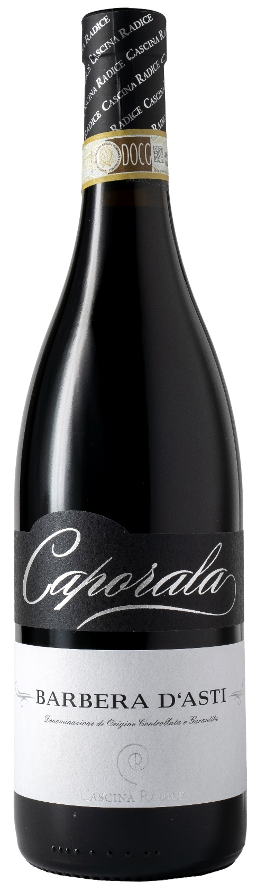
BARBERA D’ASTI DOCG – CAPORALA

Grape: Barbera 100%
Alc. Vol.%: 14
Vintage: 2024
Residual sugar g/l: 5,3
Total acidity g/l: 5,7
Region: Piedmont
Production zone: Vineyards in the area of Moasca (Province of Asti)
Capacity: 750ml

CHARACTERISTICS

Vinification: At a controlled temperature. The peel maceration takes 12 days in steel tanks
Aging: 8 months in steel tanks
Yield per ha: 9000kg
Colour: Deep, intense red
Bouquet: Fruity, winy, ethereous
Flavour: Dry, full-bodied, pleasantly balanced with tannins

SERVING SUGGESTIONS

Best with spicy starters and meat courses
Serving temperature 18 °C
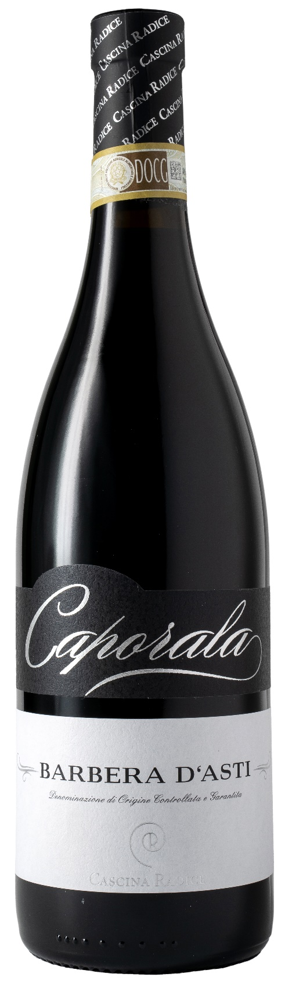
TECHNICAL INFORMATION / PALLETIZING

Size 750ml:
Article Nr. V02007A
GTIN-13 bottle 8017868004912
GTIN-13 carton 8017868004080
Closure Cork
Bottles / carton 6 bottles
Pallet size 80x120cm
Cartons/layer 21
Cartons/pallet 105
Kg/carton 8,1
Kg/pallet 870

Contains sulphites
GMO Free
Revisione 01. 21.04.2026

